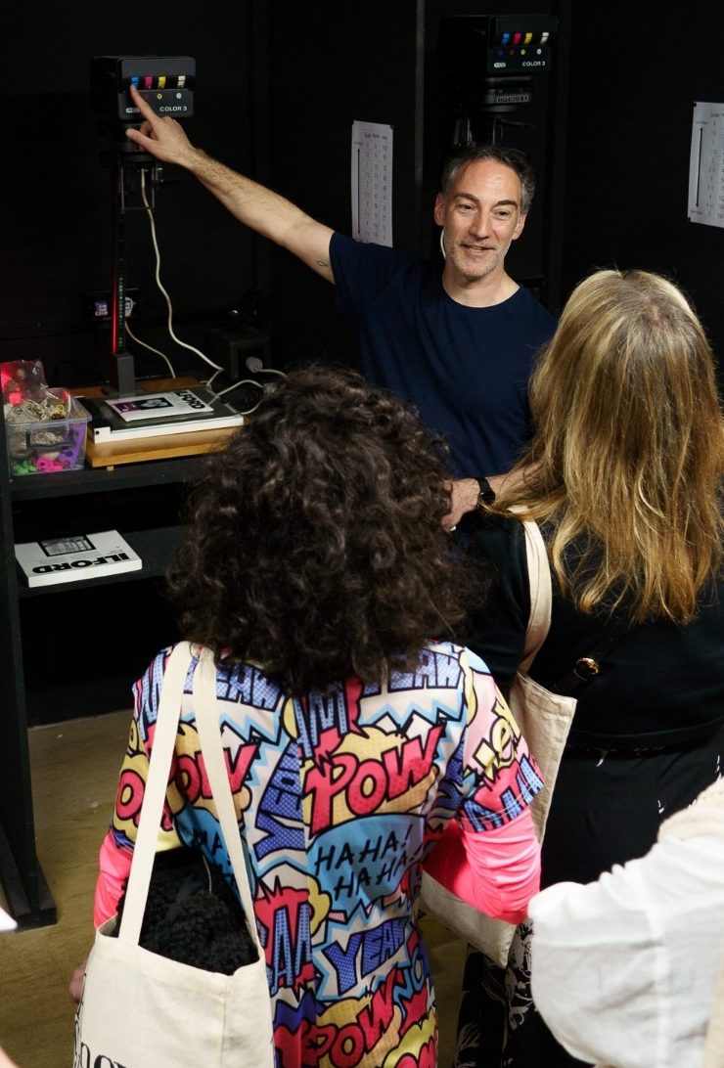
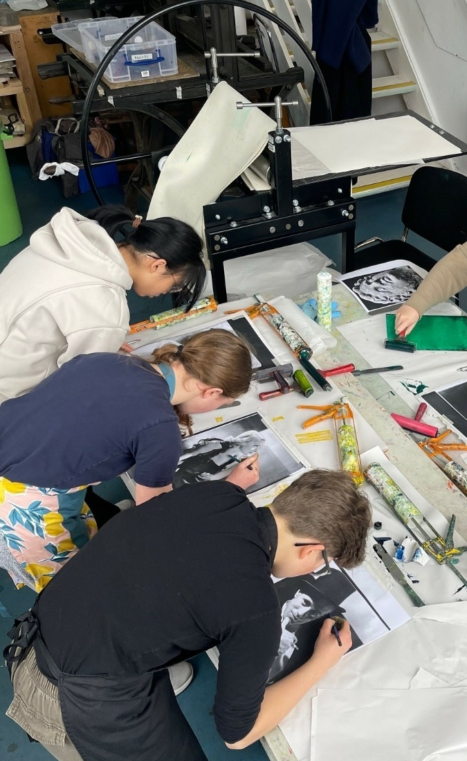
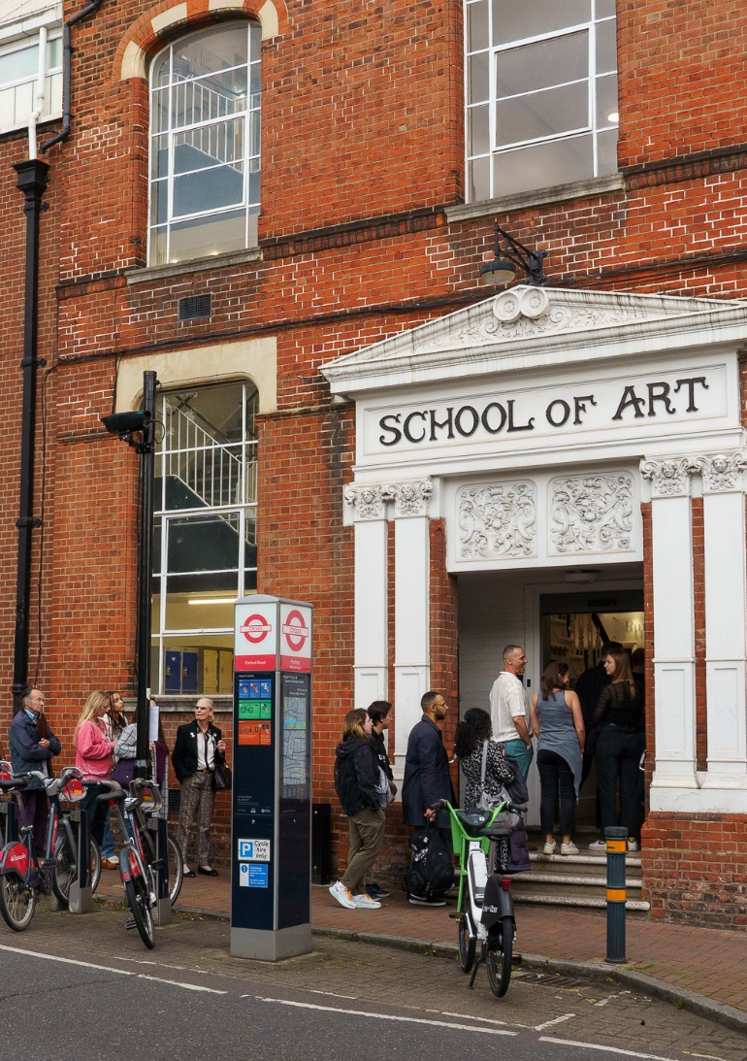

 February Start Short Course Guide 2025-2026

Specialist Courses – Art & Design for Young People

Time | Title | Tutor | Studio | Term | Start date | No. of weeks | Fee | Access for All | Course ID
Mondays
5.15 to 6.30pm | Life & Figure Drawing for Portfolio Prep 14-17 Years | Paige Barry | Studio 1 | Spring 2 | 23 Feb | 4 | £58 | £29 | 13652
 |  |  |  | Summer | 11 May | 8 | £115 | £58 | 13804
Tuesdays
5.15 to 6.30pm | Drawing & Painting Mixed Media  13-17 years (All levels) | Antonia Reina | Studio 3 | Spring 2 | 24 Feb | 4 | £48 | £24 | 13654
 |  |  |  | Summer | 12 May | 8 | £95 | £48 | 13806
Saturdays
1.30 – 4.00pm | Kids Pottery Club 8-12 years | Sarah Deeks | 3D  Pottery 2 | Spring 2 | 28 Feb | 5 | £143 | £72 | 13658
 |  |  |  | Summer | 2 May | 10 | £285 | £143 | 13810

Specialist Courses – Pay As You Go & Open Studios

Pottery PAYG Option Wednesdays 4.15- 6.30pm Fees: £32 standard or £24 concession (or you can enrol for the term as above)

Pottery Fridays 2-5pm Fees: £42 standard or £32 concession (Please check each term for availability)

NEW: Independent Practice Saturdays 10am – 1pm Fees: £29 standard or £23 concession (or you can enrol for the term as above)
(Painting)

NEW: Independent Practice Sundays 10am–1pm or 1.30pm–4.30pm Fees: £27.50 standard or £22.50 concession (or you can enrol for the term)
(Pottery)

Portrait Drawing & Painting Saturdays 1.30pm – 4.30pm Fees: £42 flat rate for each class or £32 concessions (including life model)

Screenprinting Saturdays 1.30 – 4.30pm Fees: £42 standard or £32 concession (Including all inks)
Mons & Tues 6.45-9.45pm Fees: £42 standard or £32 concession (Including all inks)

(PAYG Screenprinting is only available from the 3rd week and reserved for current PSAD print students as opportunity to work on existing projects)

Putney School of Art and Design: 2025-2026 Programme Mondays

Time | Title | Tutor | Studio | Term | Start date | No. of weeks | Fee | Resident 60+ Fee | Access for All | Course ID
Morning
10 to 1pm | Screenprinting (All levels) | Daisy Jarrett | Print | Spring 2 | 23 Feb | 6 | £200 | £105 | £100 | 13668
 |  |  |  | Summer | 20 April | 12 | £399 | £309 | £200 | 13820
10 to 1pm | Pottery (All levels) | J Dawson/C Greenaway | 3D  Pottery 1 | Spring 2 | 23 Feb | 6 | £200 | £105 | £100 | 13669
 |  |  |  | Summer | 20 April | 12 | £399 | £309 | £200 | 13821
10 to 1pm | Pottery (All levels) | Leigh Jenkinson | 3D  Pottery 2 | Spring 2 | 23 Feb | 6 | £200 | £105 | £100 | 13672
 |  |  |  | Summer | 20 April | 12 | £399 | £309 | £200 | 13824

Afternoon
2 to 5pm | Figurative Art (All levels) | Stephen Gregson | Studio 1 | Spring 2 | 23 Feb | 6 | £220 | £175 | £100 | 13674
 |  |  |  | Summer | 20 April | 12 | £439 | £349 | £200 | 13826
2 to 5pm | Screenprinting (All levels) | Daisy Jarrett | Print | Spring 2 | 23 Feb | 6 | £200 | £105 | £100 | 13677
 |  |  |  | Summer | 20 April | 12 | £399 | £309 | £200 | 13829
1.30 to 4.30pm | Pottery (All levels) | J Dawson/C Greenaway | 3D  Pottery 1 | Spring 2 | 23 Feb | 6 | £200 | £105 | £100 | 13678
 |  |  |  | Summer | 20 April | 12 | £399 | £309 | £200 | 13830

Evening
6.30 to 9.00pm | Watercolour (Flora & Fauna) for Beginners / Intermediate | Paige Barry | Studio 3 (Roof) | Spring 2 | 23 Feb | 5 | £125 | £94 | £63 | 13685
 |  |  |  | Summer | 27 April | 10 | £250 | £188 | £125 | 13837
6.30 to 9.30pm | Screenprinting (All levels) | Ben Rider | Print | Spring 2 | 23 Feb | 16 | £200 | £105 | £100 | 13686
 |  |  |  | Summer | 20 April | 12 | £399 | £309 | £200 | 13838
6.30 to 9.30pm | NEW Botanic Drawing & Painting (All Levels) - Putney School of Art and Design | Jaco Nel | Studio 5 | Spring 2 | 23 Feb | 5 | £125 | £95 | £65 | 14477

Putney School of Art and Design: 2025-2026 Programme Tuesdays
Time | Title | Tutor | Studio | Term | Start date | No. of weeks | Fee | Resident 60+ Fee | Access for All | Course ID
Morning
10 to 1pm | Pottery (All levels) | Hazel Richards | 3D  Pottery 1 | Spring 2 | 24 Feb | 6 | £200 | £155 | £100 | 13697
 |  |  |  | Summer | 21 April | 12 | £399 | £309 | £200 | 13848
10 to 1pm | Photoclub for Advanced Photographers | Neil White | Digital | Spring 2 | 24 Feb | 5 | £158 | £118 | £79 | 13698
 |  |  |  | Summer | 28 April | 10 | £315 | £236 | £158 | 13849
10 – 1pm | Watercolour Painting (All Levels) | Shaun Carey | Studio 4 | Spring 2 | 24 Feb | 6 | £180 | £135 | £90 | 13699
 |  |  |  | Summer | 21 April | 12 | £360 | £270 | £180 | 13850
10 – 1pm | Expressive Drawing & Painting: Flora & Natural Form | Sarah Sparkes | Studio 5 | Spring 2 | 24 Feb | 6 | £180 | £135 | £90 | 13700
 |  |  |  | Summer | 21 April | 12 | £360 | £270 | £180 | 13851
10 – 1pm | Pottery (All levels) | Leigh Jenkinson | 3D  Pottery 2 | Spring 2 | 24 Feb | 6 | £200 | £155 | £100 | 13701
 |  |  |  | Summer | 21 April | 12 | £399 | £309 | £200 | 13852

Afternoon
2 to 5pm | Drawing on Location - Putney School of Art and Design | Jan Malaszek | Location / Studio | Spring 2 | 24 Feb | 6 | £180 | £135 | £90 | 13711
 |  |  |  | Summer 2 | 9 June | 6 | £180 | £135 | £90 | 13862
2 – 5pm | Watercolour Painting (All Levels) | Paul Dixon | Studio 4 | Spring 2 | 24 Feb | 5 | £150 | £125 | £75 | 13710
 |  |  |  | Summer | 28 April | 10 | £300 | £225 | £150 | 13861

Evening
6.30 to 9.30pm | Fine Art Textiles | Jane Millar | Studio 4 | Spring 2 | 24 Feb | 6 | £188 | £148 | £94 | 13712
 |  |  |  | Summer | 21 April | 12 | £375 | £295 | £188 | 13863
6.30 to 9.30pm | Drawing & Painting (Intermediate level) | Jan Malaszek | Studio 1 | Spring 2 | 24 Feb | 6 | £180 | £135 | £90 | 13713
 |  |  |  | Summer | 21 April | 12 | £360 | £270 | £180 | 13864
6.30 to 9.30pm | Portraiture (All Levels) | Stephen Gregson | Studio 2 | Spring 2 | 24 Feb | 5 | £184 | £146 | £93 | 13714
 |  |  |  | Summer | 28 April | 10 | £366 | £291 | £183 | 13865
6.30 to 9.30pm | Screenprinting (All levels) | Ben Rider | Print | Spring 2 | 24 Feb | 6 | £200 | £155 | £100 | 13715
 |  |  |  | Summer | 21 April | 12 | £399 | £309 | £200 | 13866
6.45 to 9.15pm | Expressive Pastels (All Levels) | Shaun Carey | Studio 3 (Roof) | Spring 2 | 24 Feb | 6 | £150 | £123 | £75 | 13717
 |  |  |  | Summer | 21 April | 12 | £300 | £225 | £150 | 13868
6.45 to 9.45pm | Pottery (All levels) | E Radlinska/  L Jenkinson* | 3D  Pottery 2 | Spring* 2 | 24 Feb | 6 | £200 | £155 | £100 | 13719
 |  |  |  | Summer | 21 April | 12 | £399 | £309 | £200 | 13870

Putney School of Art and Design: 2025-2026 Programme Wednesdays

Time | Title | Tutor | Studio | Term | Start date | No. of weeks | Fee | Resident 60+ Fee | Access for All | Course ID
Morning
10 to 1pm | Screenprinting (All levels) | Daisy Jarrett | Print | Spring 2 | 25 Feb | 6 | £200 | £155 | £100 | 13724
 |  |  |  | Summer | 22 April | 12 | £399 | £309 | £200 | 13874
10 to 1pm | Introduction to Drawing | Shaun Carey | Studio 4 | Spring 2 | 25 Feb | 6 | £180 | £135 | £900 | 13726
 |  |  |  | Summer | 22 April | 12 | £360 | £270 | £180 | 13876

Time | Title | Tutor | Studio | Term | Start date | No. of weeks | Fee | Resident 60+ Fee | Access for All | Course ID
Afternoon
2 to 5pm | Life & Portrait Drawing (All levels) | Annabel Cullen | Studio 1 | Spring 2 | 25 Feb | 6 | £220 | £175 | £110 | 13729
 |  |  |  | Summer | 22 April | 12 | £439 | £349 | £220 | 13879
2 to 5pm | Screenprinting (All levels) | Daisy Jarrett | Print | Spring 2 | 25 Feb | 6 | £200 | £155 | £100 | 13732
 |  |  |  | Summer | 22 April | 12 | £399 | £309 | £200 | 13882
1.30 to 4pm | Pottery (All levels) | D Jones/ C Greenaway | 3D  Pottery 1 | Spring 2 | 25 Feb | 6 | £158 | £130 | £84 | 13733
 |  |  |  | Summer | 22 April | 12 | £335 | £259 | £168 | 13883

Time | Title | Tutor | Studio | Term | Start date | No. of weeks | Fee | Resident 60+ Fee | Access for All | Course ID
Evening
6.45 to 9.15pm | Life Drawing (All levels) | Eithne Healy | Studio 1 | Spring 2 | 25 Feb | 6 | £185 | £146 | £92 | 13737
 |  |  |  | Summer | 22 April | 12 | £366 | £291 | £183 | 13887
6.30 to 9.30pm | Drawing & Painting (All levels) | Ian Ellis/ Jost Münster* | Studio 2 | Spring*2 | 25 Feb | 6 | £180 | £135 | £90 | 13738
 |  |  |  | Summer | 22 April | 12 | £360 | £270 | £180 | 13888
6.30 to 9.00pm | Watercolour Painting (All Levels) | Sophie Ambrose | Studio 3  (Roof) | Spring 2 | 25 Feb | 5 | £125 | £94 | £63 | 13739
 |  |  |  | Summer 1 | 29 April | 10 | £250 | £188 | £125 | 13889
6.30 to 9.30pm | Lino Printing (All Levels) | Paul Schofield | Studio 4 | Spring 2 | 25 Feb | 6 | £200 | £155 | £100 | 13741
 |  |  |  | Summer | 22 April | 12 | £399 | £309 | £200 | 13891
6.45 to 9.45pm | Pottery (All levels) | Regina Heinz | 3D  Pottery 1 | Spring 2 | 25 Feb | 12 | £200 | £155 | £100 | 13742
 |  |  |  | Summer | 22 April | 12 | £399 | £309 | £200 | 13892
Putney School of Art and Design: 2025-2026 Programme Thursdays

Time | Title | Tutor | Studio | Term | Start date | No. of weeks | Fee | Resident 60+ Fee | Access for All | Course ID
Morning
10am to 1pm | Life Drawing (Beg / Refresher) | Annabel Cullen | Studio 1 | Spring 2 | 26 Feb | 6 | £220 | £175 | £110 | 13745
 |  |  |  | Summer | 23 April | 12 | £439 | £349 | £220 | 13895
10am to 1pm | Drawing Projects (All Levels) | Jan Malaszek | Studio 5 | Spring 2 | 26 Feb | 5 | £150 | £115 | £75 | 13752
 |  |  |  | Summer | 30 April | 10 | £300 | £225 | £150 | 13902

Afternoon
2.30 to 5.30pm |  | Painting Open Studio (Advanced workshop) | Sarah Sparkes | Studio 1 | Spring 2 | 26 Feb | 6 | £180 | £135 | £90 | 13754
 |  |  |  |  | Summer | 23 April | 12 | £360 | £270 | £180 | 13904
2 to 5pm |  | Pottery (All levels) | Dante Pertusini | 3D  Pottery 1 | Spring 2 | 26 Feb | 6 | £200 | £155 | £100 | 13758
 |  |  |  |  | Summer | 23 April | 12 | £399 | £309 | £200 | 13908
2 to 5pm | Egg Tempera |  | Paige Barry | Studio 4 | Spring 2 | 26 Feb | 6 | £180 | £135 | £90 | 13759
 |  |  |  |  | Summer | 23 April | 12 | £360 | £270 | £180 | 13909
2 to 5pm | Intro to Watercolour & Experimental Techniques |  | Kaitlyn Watson | Studio 5 | Spring 2 | 26 Feb | 5 | £150 | £115 | £75 | 13760
 |  |  |  |  | Summer | 30 Apr | 10 | £300 | £225 | £150 | 13910

Evening
6.30 to 9.30pm | Oil Painting (Intermediate) | Eithne Healy | Studio 1 | Spring 2 | 26 Feb | 6 | £180 | £135 | £90 | 13763
 |  |  |  | Summer | 23 April | 12 | £360 | £270 | £180 | 13913
6.30 to 9.30pm | Improvers Painting & Drawing | Jan Malaszek | Studio 2 | Spring 2 | 26 Feb | 6 | £180 | £135 | £90 | 13764
 |  |  |  | Summer | 23 April | 12 | £360 | £270 | £180 | 13914
6.30 to 9.00pm | NEW Good Artists: Portraiture (All Levels)/Paint like the Great Masters* | Ian Ellis/Paige Barry* | Studio 3  (Roof) | Spring* 2 | 26 Feb | 5 | £183 | £145 | £95 | 13765
 |  |  |  | Summer | 30 Apr | 10 | £365 | £291 | £153 | 13915
6.30 to 9.30pm | Experimental Printmaking (All levels) | Paul Schofield | Studio 4 | Spring 2 | 26 Feb | 5 | £165 | £130 | £84 | 13768
 |  |  |  | Summer | 30 Apr | 10 | £333 | £258 | £167 | 13918
Putney School of Art and Design: 2025-2026 Programme Fridays

Time | Title | Tutor | Studio | Term | Start date | No. of weeks | Fee | Resident 60+ Fee | Access for All | Course ID
Morning
10am to 1pm | Life Drawing & Painting (All levels) | Jan Malaszek | Studio 1 | Spring 2 | 27 Feb | 5 | £183 | £145 | £92 | 13770
 |  |  |  | Summer | 24 April | 12 | £439 | £349 | £220 | 13920
10am to 1pm | Illustration (All Levels) | Sophie Ambrose | Studio 3  (Roof) | Spring 2 | 27 Feb | 5 | £150 | £115 | £75 | 13772
 |  |  |  | Summer | 1 May | 10 | £300 | £225 | £150 | 13922
10am to 1pm | Pottery (All levels) | Malindi O’Rorke | 3D  Pottery 2 | Spring 2 | 27 Feb | 5 | £166 | £129 | £83 | 13774
 |  |  |  | Summer | 24 April | 12 | £399 | £309 | £200 | 13924
10am to 1.30pm | Lithography (All levels) | Simon Burder | Studio 4 | Spring 2 | 27 Feb | 5 | £195 | £155 | £98 | 13777
 |  |  |  | Summer | 24 April | 12 | £469 | £365 | £235 | 13928
10am to 1pm | Introduction to Drawing | Kaitlyn Watson | Studio 5 | Spring 2 | 27 Feb | 5 | £150 | £115 | £75 | 13778
 |  |  |  | Summer | 1 May | 10 | £300 | £225 | £150 | 13929

Afternoon
2 to 5pm | Pottery (All levels) | Malindi O’Rorke | 3D  Pottery 2 | Spring 2 | 27 Feb | 5 | £166 | £129 | £83 | 13783
 |  |  |  | Summer | 24 April | 12 | £399 | £309 | £200 | 13934
2 to 5pm | Lino Printing (All Levels) | Raquel Amatparra | Studio 4 | Spring 2 | 27 Feb | 5 | £166 | £129 | £83 | 13792
 |  |  |  | Summer | 24 April | 12 | £399 | £309 | £200 | 13935
2 to 5pm | Sculpture in Ceramics, from life model | Eithne Healy | 3D  Pottery 1 | Spring 2 | 27 Feb | 5 | £199 | £165 | £100 | 13793
 |  |  |  | Summer | 24 April | 12 | £479 | £389 | £240 | 13936
2 to 5pm | Drawing & Colour  (All Levels) | Sophie Ambrose | Studio 5 | Spring 2 | 27 Feb | 5 | £150 | £115 | £75 | 13794
 |  |  |  | Summer | 1 May | 10 | £300 | £225 | £150 | 13937

Putney School of Art and Design: 2025-2026 Programme Saturdays

Time | Title | Tutor | Studio | Term | Start date | No. of weeks | Fee | Resident 60+ Fee | Access for All | Course ID
Morning
10am to 1pm | NEW: Independent Practice (Fine Art) PAYG Option available, details on page 3) | N/A Independent Work | Studio 2 | Spring 2 | 28 Feb | 6 | £120 | £95 | £600 | 13662
 |  |  |  | Summer | 25 April | 12 | £240 | £185 | £120 | 13814
10am to 1pm | Drawing & Painting (All levels) | Ian Ellis/ J Malaszek* /SGregson* | Studio 1 | Spring* 2 | 28 Feb | 6 | £180 | £135 | £90 | 13796
 |  |  |  | Summer | 25 April | 12 | £360 | £270 | £180 | 13939
10am to 1pm | Watercolour Painting (All levels) | Paul Dixon | Studio 3  (Roof) | Spring 2 | 28 Feb | 6 | £180 | £135 | £90 | 13797
 |  |  |  | Summer | 25 April | 12 | £360 | £270 | £180 | 13940
10am to 1pm | Screenprinting (All levels) | Ben Rider | Print | Spring 2 | 28 Feb | 6 | £200 | £155 | £100 | 13798
 |  |  |  | Summer | 25 April | 12 | £399 | £309 | £200 | 13941

Afternoon
1.30 to 4.30pm | Portrait Drawing & Painting / PAYG (All levels) | S Gregson & P Schofield* | Studio 1 | Spring* 2 | 28 Feb* | 6 | £220 | £175 | £110 | 13663
 |  |  |  | Summer | 25 April | 12 | £439 | £349 | £220 | 13815
1.30 to 4.30pm | Approaches to Oil Painting | Ian Ellis/ J Malaszek* /SGregson* | Studio 2 | Spring* 2 | 28 Feb | 6 | £180 | £135 | £90 | 13800
 |  |  |  | Summer | 25 April | 12 | £360 | £270 | £180 | 13943
1.30 to 4.30pm | Screenprinting (All levels) | Ben Rider | Print | Spring 2 | 28 Feb | 6 | £200 | £155 | £100 | 13801
 |  |  |  | Summer | 25 April | 12 | £399 | £309 | £200 | 13944
1.30 to 4.30pm | Pottery (All levels) | J Dawson/C Greenaway | 3D  Pottery 1 | Spring 2 | 28 Feb | 6 | £200 | £155 | £100 | 13802
 |  |  |  | Summer | 25 April | 12 | £399 | £309 | £200 | 13945
1.30 to 4.30pm | NEW Watercolour for Beginners | Paul Dixon | Studio 3 | Spring 2 | 28 Feb | 5 | £150 | £115 | £75 | 13803
 |  |  |  | Summer | 2 May | 10 | £300 | £225 | £150 | 13946
Putney School of Art and Design: 2025-2026 Programme Sundays

Time | Title | Tutor | Studio | Term | Start date | No. of weeks | Fee | Resident 60+ Fee |  | Access for All | Course ID
Afternoon
10am to 1pm | Pottery (All levels) | Carol Greenaway | 3D  Pottery 1 | Spring 2 | 1 March | 6 | £199 | £155 |  | £100 | 14127
 |  |  |  | Summer 1 | 26 April | 6 | £199 | £155 |  | £100
 |  |  |  | Summer 1 | 14 June | 6 | £199 | £155 |  | £100
1.30 to 4.30pm | Pottery (All levels) | Carol Greenaway | 3D  Pottery 1 | Spring 2 | 1 March | 6 | £199 | £155 |  | £100 | 14129
 |  |  |  | Summer 1 | 26 April | 6 | £199 | £155 |  | £100
 |  |  |  | Summer 1 | 14 June | 6 | £199 | £155 |  | £100
10am to 1pm | New Independent Practice: Pottery | N/A Independent Work | 3D  Pottery 2 | Spring 2 | 1 March | 6 | £150 | £113 | £75 |  | 14131
 |  |  |  | Summer 1 | 26 April | 6 | £150 | £113 | £75
 |  |  |  | Summer 1 | 14 June | 6 | £150 | £113 | £75
1.30 to 4.30pm | New Independent Practice: Pottery | N/A Independent Work | 3D  Pottery 2 | Spring 2 | 1 March | 6 | £150 | £113 | £75 |  | 14133
 |  |  |  | Summer 1 | 26 April | 6 | £150 | £113 | £75
 |  |  |  | Summer 1 | 14 June | 6 | £150 | £113 | £75

We also have short intensive, including one day, courses throughout the year.

Please see ‘Specialist & Holiday Courses’ section on our website www.enablelc.org/psad for regular updates.

Putney School of Art and Design: 2025-2026 Academic Calendar

 | Aug-25 | September | October | November | December | January | February | March | April | May | June | July | Aug-26
Weds |  |  | 1 |  |  |  |  |  | 1 |  |  | 1 |  | Weds
Thurs |  |  | 2 |  |  | 1 NY's Day |  |  | 2 |  |  | 2 |  | Thurs
Fri | 1 |  | 3 |  |  | 2 |  |  | 3 Good Friday | 1 |  | 3 |  | Fri
Sat | 2 |  | 4 | 1 |  | 3 | 1 |  | 4 | 2 |  | 4 | 1 | Sat
Sun | 3 |  | 5 | 2 |  | 4 | 1 | 1 | 5 | 3 |  | 5 | 2 | Sun
Mon | 4 | 1 | 6 | 3 | 1 | 5 | 2 | 2 | 6 Easter Mon | 4 BH | 1 | 6 | 3 | Mon
Tues | 5 | 2 | 7 | 4 | 2 | 6 | 3 | 3 | 7 | 5 | 2 | 7 | 4 | Tues
Weds | 6 | 3 | 8 | 5 | 3 | 7 | 4 | 4 | 8 | 6 | 3 | 8 | 5 | Weds
Thurs | 7 | 4 | 9 | 6 | 4 | 8 | 5 | 5 | 9 | 7 | 4 | 9 | 6 | Thurs
Fri | 8 | 5 | 10 | 7 | 5 | 9 | 6 | 6 | 10 | 8 | 5 | 10 | 7 | Fri
Sat | 9 | 6 | 11 | 8 | 6 | 10 | 7 | 7 | 11 | 9 | 6 | 11 | 8 | Sat
Sun | 10 | 7 | 12 | 9 | 7 | 11 | 8 | 8 | 12 | 10 | 7 | 12 | 9 | Sun
Mon | 11 | 8 | 13 | 10 | 8 | 12 | 9 | 9 | 13 | 11 | 8 | 13 | 10 | Mon
Tues | 12 | 9 | 14 | 11 | 9 | 13 | 10 | 10 | 14 | 12 | 9 | 14 | 11 | Tues
Weds | 13 | 10 | 15 | 12 | 10 | 14 | 11 | 11 | 15 | 13 | 10 | 15 | 12 | Weds
Thurs | 14 | 11 | 16 | 13 | 11 | 15 | 12 | 12 | 16 | 14 | 11 | 16 | 13 | Thurs
Fri | 15 | 12 | 17 | 14 | 12 | 16 | 13 | 13 | 17 | 15 | 12 | 17 | 14 | Fri
Sat | 16 | 13 | 18 | 15 | 13 | 17 | 14 | 14 | 18 | 16 | 13 | 18 | 15 | Sat
Sun | 17 | 14 | 19 | 16 | 14 | 18 | 15 | 15 | 19 | 17 | 14 | 19 | 16 | Sun
Mon | 18 | 15 | 20 | 17 | 15 | 19 | 16 | 16 | 20 | 18 | 15 | 20 | 17 | Mon
Tues | 19 | 16 | 21 | 18 | 16 | 20 | 17 | 17 | 21 | 19 | 16 | 21 | 18 | Tues
Weds | 20 | 17 | 22 | 19 | 17 | 21 | 18 | 18 | 22 | 20 | 17 | 22 | 19 | Weds
Thurs | 21 | 18 | 23 | 20 | 18 | 22 | 19 | 19 | 23 | 21 | 18 | 23 | 20 | Thurs
Fri | 22 | 19 | 24 | 21 | 19 | 23 | 20 | 20 | 24 | 22 | 19 | 24 | 21 | Fri
Sat | 23 | 20 | 25 | 22 | 20 | 24 | 21 | 21 | 25 | 23 | 20 | 25 | 22 | Sat
Sun | 24 | 21 | 26 | 23 | 21 | 25 | 22 | 22 | 26 | 24 | 21 | 26 | 23 | Sun
Mon | 25 BH | 22 | 27 | 24 | 22 | 26 | 23 | 23 | 27 | 25 BH | 22 | 27 | 24 | Mon
Tues | 26 | 23 | 28 | 25 | 23 | 27 | 24 | 24 | 28 | 26 | 23 | 28 | 25 | Tues
Weds | 27 | 24 | 29 | 26 | 24 | 28 | 25 | 25 | 29 | 27 | 24 | 29 | 26 | Weds
Thurs | 28 | 25 | 30 | 27 | 25 Christmas | 29 | 26 | 26 | 30 | 28 | 25 | 30 | 27 | Thurs
Fri | 29 | 26 | 31 | 28 | 26 Boxing | 30 | 27 | 27 |  | 29 | 26 | 31 | 28 | Fri
Sat | 30 | 27 |  | 29 | 27 | 31 | 28 | 28 |  | 30 | 27 |  | 29 | Sat
Sun | 31 | 28 |  | 30 | 28 |  |  | 29 |  | 31 | 28 |  | 30 | Sun
Mon |  | 29 |  |  | 29 |  |  | 30 |  |  | 29 |  | 31 BH | Mon
Tues |  | 30 |  |  | 30 |  |  | 31 |  |  | 30 |  |  | Tues
Weds |  |  |  |  | 31 |  |  |  |  |  |  |  |  | Weds
Thurs |  |  |  |  |  |  |  |  |  |  |  |  |  | Thurs
 | Weekends | School Open | Summer Closure | Half term | Christmas | Easter | BH | Summer School | Induction week

Refunds and Cancellation Policy

- Please be sure to read the details of the School’s policy for refunds in the event of the cancellation of a course by the school or the withdrawal from a course by a student before you enrol and pay for your course. Your enrolment on a course will be taken to show that you accept the conditions of this refund policy.

- If the school cancels a course it will offer all students the alternative of a full refund or transfer to another course. Should the student opt for a refund, they will need to contact the school with their debit or credit card details so that we can refund the amount directly to the account. There will be no charge for this service.

- The following rules apply should a student wish to withdraw from a course;
- Requests for withdrawals and refunds must be received in writing, preferably by email to the school email address below.
- If you withdraw from the course more than 7 days in advance of the course starting you will receive a refund, minus 10% of the full course fee and not the concession fee, for administration cost.
- If you withdraw from your course less than 7 days in advance of the course starting or once the course has started you will not be eligible for a refund of any kind, unless this is due to a course being proved to have been mis-sold by the School or to service failure.

- You can transfer from one course to another (in the same term) before the course has started or after the first teaching session. You may do so without charge, subject to availability, by arranging this with the Admin Team via email/in writing. The transfer is available once per term only. We are unable to offer transfers after week 2.

- Should you request a refund based on a complaint about the quality of service provided by the School, your complaint will be dealt with from the time that your complaint is received by the Head of School for Putney School of Art and Design. Your complaint must be received in writing, preferably by email to the school email address; psad@enablelc.org. The date of receipt of your claim will be the date from which your complaint is considered to have started. If we substantiate your claim, you will receive a proportional refund of the fees paid. If we do not substantiate your claim, you will not be entitled to a refund.

- We regret that we are unable to offer refunds under any other circumstances i.e. absence due to medical conditions, changes to work commitments, bereavements or other reasons for not being able to attend the course as a part or a whole. In addition, it is not possible to make up missed classes and get a refund or a credit for them.

Putney School of Art & Design
PSAD Website: www.psad.org.uk
Email: psad@enablelc.org
Telephone: 020 3959 0110
Oxford Road
London
SW15 2LQ

3D Campus:
Bentley House, 4a Disraeli Road
(Just off Putney High Street and directly opposite Putney Library)
N.B Classes in 3D Studio 1 and 3D Sculpture Studio are not yet accessible for wheelchair users (Staircase leading to first floor).
Please speak to the Admin Team
who will advise an alternative course at Oxford Road site

